Mapping the Ocean Floor Name: ___________________________________________________
Instructions and data sheet

Background:

The surface of the oceans covers an area of more than 12 million square km! Did you ever wonder what was below the surface of all that water? Many early explorers did, and they used several methods to try to determine the shape of the ocean floor. At one time, sailors tied weights to the end of ropes and lowered them to the ocean floor, marked the distance when the rope hit bottom, and then measured that distance. You can imagine what a slow process this was!
In the early 1900s, sonar was invented by a French scientist. He used this technology to get sound wave readings of the ocean floor. This was a great discovery because it allowed scientists to get faster and more accurate readings. A device called an “echo sounder” is simply aimed downward, at which point it gives off a sound signal. The sound signal travels to the ocean floor and bounces, or “echoes”, off the surface. The device picks up the echo and then computes the ocean depth at that point. To do this calculation yourself, all you need to know is the speed of sound in water (1,500 m/s), and the time it took for the sound signal to echo.
During this activity, you will use this method to construct a map for two different regions of the ocean floor.

Procedures:

Part 1: Atlantic Profile
- Compute the Total Distance Traveled by multiplying the Time for the Signal to Return by the speed of sound (1,500 m/s), and record this distance on the data table on the back of this sheet.
- Divide your Total Distance Traveled by 2 to get your Ocean Depth in meters. Record this depth on the data table. This Ocean Depth data is what you will be graphing.
- Along the bottom of the graph, label the x-axis as “Distance from Beach (km)”, and set up the scale, counting by 100’s.
- On the “Mapping the Ocean Floor Lab” handout, plot the Distance from Beach (x-axis) vs. Ocean Depth (y-axis) for the Atlantic Profile graph. Sea level (0 meters) is the line already shown on the graph.
- Once the points are plotted, connect the points and shade in the profile of the ocean floor.
- Label the following ocean floor features on your graph. Use page 48 and 49 as a reference.

Continental Shelf, Continental Slope, Continental Rise, Island, Mid-ocean ridge, Abyssal Plain

Part 2: Pacific Profile
- Label the x-axis as “Distance from Beach (km)”, and set up the scale, this time counting by 8.
- On the “Mapping the Ocean Floor Lab” handout, plot the Distance from Beach ( x-axis) vs. Ocean Depth (y-axis) for the Pacific Profile graph. For this set of data, the depth has already been calculated for you.
- Once the points are plotted, connect the points and shade in the profile of the ocean floor.
- Label the following ocean floor features on your graph. Use page 48 and 49 as a reference.

Continental Slope [directly next to shore], Seamounts [next to the subduction zone], Trench [the deep one]

Part 3: Labeling

- The Pacific Profile shows the Pacific Plate subducting beneath the Philippine Plate. Beneath the ocean floor on this profile, sketch what you think the subduction zone would look like (HINT → Show one plate going under the other). Label these two plates; then draw in the rising magma that is leading to the creation of the seamounts.

- In this activity you created two different ocean floor profiles. One major difference between the two profiles is the scale of the distance from the shore. Even though both of your profile pictures cover the width of your paper, they do NOT represent the same distance. You need to get a sense of how each of the two profiles compare to each other.
  - First determine how wide the entire Pacific Profile is (in km): __________
  - Now take that number and find where that same distance would be along the Atlantic Profile. Draw a vertical dotted line at this point.
  - Use a colored pencil (any color) to lightly shade in everything to the left of this dotted line.
  - Using the same colored pencil, write “Width of Pacific Profile” under this shaded section.

* When finished with Parts 1 – 3, answer all discussion questions in complete sentences. *
This column is what you’re
graphing on the Y-axis for

Data for Atlantic Profile the Atlantic Profile. Data for Pacific Profile

Name: __________________________________________________________________ Period: _________ Date: _____________

Mapping the Ocean Floor Lab Atlantic Profile ( passive margin)

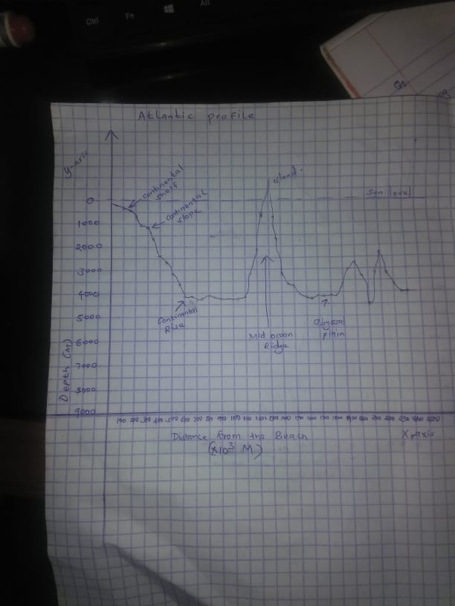

Pacific Profile ( active coast)

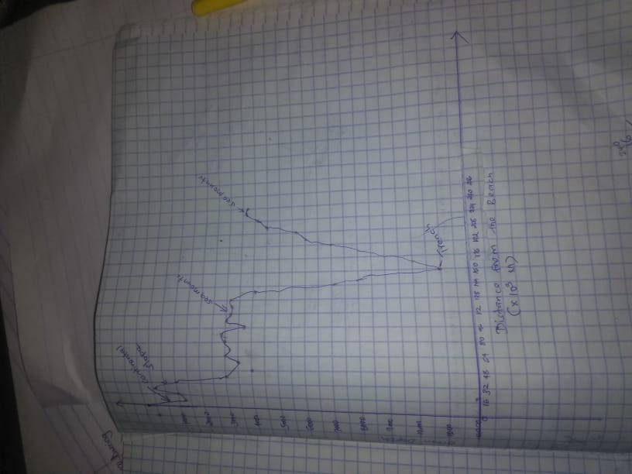

Discussion Questions:
Answer in complete sentences.

Atlantic Profile

- What two pieces of information are needed to determine ocean depth through echo-sounding?

The time taken to emit and return a pulse
The speed of sound

- Describe how a seamount could become an island. ALSO, describe how an island could become a seamount.

When volcanos erupt, the water surface is broken by the build up layers of lava, if these tops appear on top of water, an island is formed.
An island on the other hand only becomes a seamount is they is presence of both native and active volcanic activities that are able to rise the land mass above sea level.

- The island on your graph for the Atlantic Profile is part of a chain of islands located near 26°W and 38°N latitude. Use a globe or world map to locate and identify this island chain.

20.7 km (12.9 miles) NW of Mosteiro

- For the first data table, once you have found the total distance traveled by the sound wave, why is it necessary to divide it by 2? (*HINT → Think about where the sound signal has to travel.)

The light covers the distance twice since it travels to and from. Hence, dividing by two we get the distance travels by light either to the bottom of the sea or from the bottom to the top.

Pacific Profile

- This profile shows the seafloor at the Marianas Trench, the deepest known point in any of the world’s oceans. Describe what’s happening in this area to create this trench. Please write the name of the trench on your profile.
The lava at mid-ocean ridges, when fresh, lava is comparatively warm and buoyant, riding high on the underlying mantle. But as lava ages and spreads away from its source, it slowly cools and becomes increasingly dense, causing it to settle ever lower. Hence a trench is formed.

- Explain how the seamounts (between 72 km and 128 km from the shore) may have formed near this trench.

Seamounts are underwater volcano that is formed from volcanic eruption. The peaks of seamounts are often found hundreds to thousands meter below the ocean surface. When the peak is eroded over time, it will become flat. The flat top seamounts are called guyots.

Comparing the two profiles:

- How do the two profiles differ from one another? Be descriptive of each region of ocean floor.

The Pacific is actually fairly flat, like other seas, even in regions with seamounts or deep trenches. The large and sediment-covered ocean-going abyssal plains are significantly flatter than any other region of the continent.
The Pacific Ocean floor is mainly characterized by the mainland slopes falling from 200 to several thousand m over 100 km; the abysmal plains — extremely low and from 4.000 m to 6,000 m in depth; volcanic seamounts and islands; and the trenches at subduction zones up to 11,000 m in profundity.
The Atlantic ocean The main characteristics include a huge shelf of less than 250 m , a wide, deep, 4,000-6,000 m ocean plain, a mid-Atlantic ridge that in many places is shallower than 3,000 m (3,000 m) and a deep sea trench north of Puerto Rico (8,600 m).

- In oceanography, the edges of the continents are referred to as “margins”. Depending on what type of plate activity is occurring, a margin may be considered an active margin or a passive margin. Based on your knowledge of plate tectonics, which of the two profiles would you consider to be “active”, and which would be “passive”. Explain your reasoning in detail, referring to each profile. Then, label each profile as either “passive” or “active” on each graph.

The Pacific coast is an active margin, it has a small beach, high cliffs, rough seashores and sea stakes. The transition from oceanic to continental crusts which do not have an active plate limit is passive continental margins.
The Atlantic has a Passive margin, which are not tectonically active along the coast, including much of the shoreline of the Atlantic Ocean. There is a continuous rise, a very low-angle sediment ridge forming between the mainland and the abyssal plain.

